*Mohamed Gawish*

*Emma Bortone*

ABSTRACT:

The Requirements analysis and specification document (RASD) contains the descriptions of the scenarios, the use cases that describe them, and the models describing requirements and specification for the services Data4Help and AutomatedSOS offered by the company TrackMe

*2018-2019*

*Software engineering 2*

[Attirez l’attention du lecteur avec une citation du document ou utilisez cet espace pour mettre en valeur un point clé. Pour placer cette zone de texte n’importe où sur la page, faites-la simplement glisser.]

Politecnico di Milano

TrackMe Project

TrackMe Project

|  |  |
| --- | --- |
| Image associÃ©e  RASD  T |  |

# Table des matières

I. Introduction 3

I.A. Purpose 3

I.A.1. Data4Help 3

I.A.1. AutomatedSOS 3

I.B. Hypotheses on the assignment 4

I.B.1. Data4Help 4

I.B.2. AutomatedSOS 4

I.C. Scope 5

I.C.1. Data4Help 5

I.C.2. AutomatedSOS 5

I.D. Definitions, Acronyms and abbreviations 6

I.E. Revision history 6

I.F. Reference Documents 7

I.G. Document Structure 7

II. Data4Help : Overall description 8

II.A. Product perspective 8

II.B. Product functions 10

II.C. Users characteristics 11

II.D. Assumptions, dependencies and constraints 11

III. Data4Help : Specific requirements 11

III.A. External interfaces requirements 11

III.A.1. User interfaces 11

III.A.2. Hardware interfaces 17

III.A.3. Software interfaces 17

III.A.4. Communication interfaces 17

III.B. Functional requirements 17

III.C. Uses cases 19

III.D. Sequence diagrams 27

III.E. Performance requirements 31

III.F. Design constraints 32

III.F.1. Standards compliance 32

III.F.2. Hardware limitations 32

III.F.3. Any other constraint 32

III.G. Software system attributes 32

III.G.1. Reliability 32

III.G.2. Availability 32

III.G.3. Security 32

III.G.4. Maintainability 32

III.G.5. Portability 32

IV. AutomatedSOS : Overall description 33

IV.A. Product perspective 33

I.A. Product functions 34

I.B. User characteristics 34

I.C. Assumptions, dependencies and constraints 34

V. AutomatedSOS : Specific requirements 34

V.A. External interfaces requirements 34

V.A.1. User interfaces 34

V.A.2. Hardware interfaces 36

V.A.3. Software interfaces 36

V.A.4. Communication interfaces 36

V.B. Functional requirements 36

V.C. Uses cases 36

V.D. Performance requirements 38

V.E. Design Constraints 38

V.E.1. Standards compliance 38

V.E.2. Hardware limitations 38

V.E.3. Any other constraint 38

V.F. Software system attributes 38

# Introduction

## Purpose

The purpose of this document is to define the requirements analysis and specification document (RASD) of the services Data4Help and AutomatedSOS offered by the company TrackMe. This document contains the requirements of the system to be developed and its application domain. It can be used as a baseline for software evaluation and for charge control.

### Data4Help

Data4Help is a software-based service allowing third parties to monitor the location and health status of individuals. Data4Help supports the registration of individuals and of third parties.

* Individuals who register to Data4Help allow the company TrackMe to acquire their data.
* Third parties who register to Data4Help can access the data acquired by TrackMe by the mean of requests. They can request to :
  + Access to the data of a specific individual by providing a unique identifier. The request is then transferred to the individual who decide to accept or refuse it.
  + Access to anonymized data of groups of individuals. The request is accepted if the number of individuals satisfying it is higher than 1000.

When a request is approved, third parties must be able to access the previously saved data and to subscribe to the request. By subscribing, third parties will receive the new data corresponding to the request as soon as they are produced.

The goals of the service Data4Help are :

* [G 1] : Third parties must be able to request to access to the data of specific individuals or to anonymized groups of individuals.
* [G 2] : At any time, third parties should never have access to data of specific individuals without their agreement.
* [G 3] : Third parties must have the possibility to subscribe to new data if their request is accepted.
* [G 4] : Individuals must be able to consult their data and accept/refuse requests

### AutomatedSOS

AutomatedSOS is a service build on top of Data4Help, thus AutomatedSOS must verify all the requirements of the service Data4Help. In addition, AutomatedSOS offers the possibility to monitor the health of the subscribed customers and to automatically send an ambulance to the location of the customers if their health parameter are below certain thresholds.

The goal of the service AutomatedSOS is to send an ambulance to the location of the customer with a reaction time below 5 seconds from the time the parameters are below threshold.

All the goals of Data4Help are also goals of Automated SOS, but Automated have the additional goal :

* [G 5] : An ambulance is requested to the location of the customer with a reaction time below 5 seconds from the time the parameters are below threshold

## Hypotheses on the assignment

To solve the ambiguity and incompleteness of the assignment, we made some assumptions on the services Data4Help and AutomatedSOS. Those assumptions are listed in the two following paragraphs.

### Data4Help

* The data is collected by the mean of a smartwatch synchronized to a smartphone application. We made this choice because most of the smartwatches currently on the market are aimed to be linked to a smartphone through an application and we want our software to run on as many platforms as possible (design for portability)
* The subscription to a request on a group of individuals is automatically cancelled if the number of individuals whose data satisfy the request goes bellow 1000 at some point.
* The subscription to a request on a specific individual is automatically cancelled if the individual cancels his agreement.
* The user can see the data collected by the service Data4Help. Indeed, the individual must earn something in exchange for the data he agrees to share. In this case, the individual gains the ability to control his health data.
* Data4Help must respect the General Data Protection Regulation (GDPR)
* Third parties can be compagnies, organizations or persons who need to acquire data (for example students or independent data scientists).
* The service Data4Help take the form of :
  + A website and a Web API for data request.

We made this choice because using a website is the more convenient solution for a company or an organization who need to punctually acquire data and a web API is the most convenient solution for third parties who need to acquire data regularly (each hour for example)

* + A smartphone application for data acquisition.

We made the choice to consider that the individuals have some piece of Data4Help installed on their personal device which allow Data4Help to acquire their health data. The motivation for the individual to install Data4Help on his smartphone will be to observe his own health data. Other solution would be to gathers data from some other service/system but this would mean to buy the data and the delay might be more important.

### AutomatedSOS

* The service AutomatedSOS is not an independent application. The individuals who want to subscribe to AutomatedSOS will first need to download the application Data4Help on their smartphone to register to the service. We made this choice because the service AutomatedSOS is only an extension to the service Data4Help so the requirements of the service Data4Help are also requirements of the service AutomatedSOS.
* AutomatedSOS notifies the ambulance service that an ambulance needs to be sent to a certain location by sending an SMS.
* Individuals who want to subscribe to AutomatedSOS are required to have a smartwatch and to link it to their Data4Help account. Indeed, a smartphone cannot acquire the pulse rate of the user and this data is significant for detecting emergencies.
* The thresholds are defined by the third party. We choose to prevent individuals to set themselves their thresholds to avoid unnecessary SOS or a urgent situation not being detected.
* Individuals also have the possibility to download an application on their smartwatch, in addition to the app on their smartphone, although this is not mandatory for the data acquisition. This will allow the individual to have an overview of their health data by simply looking at their watch. We made this choice because the individuals who subscribe to AutomatedSOS are elderly people who might not be comfortable with smartphones.

## Scope

In this section, we will give a brief description of the world and of the shared phenomena. By “world” we intend the portion of the real world that is affected by the machine and by “machine” we mean the portion of system to be developed. A phenomenon shared by the world and the machine can either be controlled by the world and observed by the machine or controlled by the machine and observed by the world.

### Data4Help

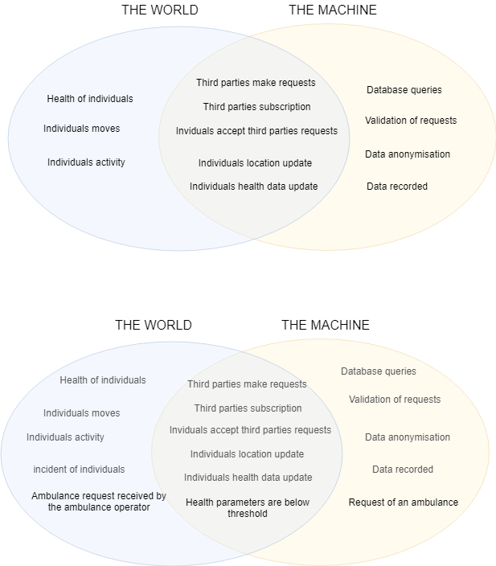

### AutomatedSOS

The world and the machine are mainly the same for the service AutomatedSOS as it is built on top of Data4Help. Indeed, AutomatedSOS must have all the functionalities of Data4Help in addition to the SOS service.



## Definitions, Acronyms and abbreviations

Third party: company or organization or person who need to access data of individuals

Individual: person willing to share his data with a third party.

Smartwatch: device aimed to be worn on the wrist. A smartwatch can collect data, can be linked to a smartphone application and can support wireless technologies like Bluetooth, Wi-Fi, and GPS.

Subscription: an arrangement for automatically receiving data corresponding to a specific accepted request as soon as the data is available and without the need to renew the request process each time.

Request: the act, for a third party, of asking for something for data. A request can be individual or anonymized.

Individual request: A request that concerns a unique person known by his fiscal code.

Anonymized request: A request that concerns a group of individuals who fit some criteria.

SOS: SMS sent by Data4Help to an ambulance service asking to send an ambulance to a specific location. An SOS is sent when the health parameters of a monitored individual go bellow threshold.

## Revision history

|  |  |  |
| --- | --- | --- |
| Version | Date | Description |
| V1.1 | 14/10/2018 | Creation of the document |
| V1.2 | 20/10/2018 | Creation of parts I (Introduction) and II (Specific requirements) |
| V1.3 | 25/10/2018 | Update of parts I and II + creation of parts III (Specific requirements) |
| V1.3 | 30/10/2018 | Update of parts I and II + creation of parts III (Specific requirements |
| V.1.final | 8/11/2018 | Update parts I, II and III. Verification coherence of the document. |

## Reference Documents

[1] SOMMERVILE, Iam. *Software engineering 9*. International edition.

[2] Assignment *Mandatory Project: goal schedule, and rules*.

[3] Les numériques, *COMPARATIF / Quelle montre connectée choisir ?*

https://www.lesnumeriques.com/montre-connectee/comparatif-montres-connectees-a1781.html

## Document Structure

This document contains the requirements analysis of two services: the service Data4Help and the service AutomatedSOS. The description of the two services is kept separated as the service Data4Help has to exists independently of the existence of the service AutomatedSOS. Indeed, the service AutomatedSOS is built after the service Data4Help and on top of it.

* The first section concerns the service Data4Help and contains three subsections:
  + **Overall description** which gives a general description of the software to be. This includes a domain model and the domain assumptions, the description of the most important requirements and the description of the user characteristics
  + **Specific requirements** which gives a more detailed description of the software. This chapter includes the description of the external interface requirements, the list of the functional and nonfunctional requirements and of the performance requirements. Furthermore, this chapter describes the design constraints and the software system attributes.

- The **functional requirements** specify what the product or service must do. They are actions that the product or service must take, such as check, calculate, record, and retrieve.

- The **non-functional requirements** demonstrate the properties that the product or service should have to do what it must do. These requirements are the characteristics or qualities that make the product or service attractive, or usable, or fast, or reliable. Most non-functional requirements are associated with performance criteria and are usually those requirements that establish the product or service boundary.

- The **constraints** can be of two types: design constraints and project constraints. Design constraints are those pre-existing design decisions that mandate how the final product must look or how it must comply technologically. Project constraints cover the areas of budget and schedule along with deadlines.

* The second section is about the service AutomatedSOS and has the same structure has the previous one.
* This document contains also a section called **Formal analysis using Alloy** which includes the alloy model of the software and the discussion of its purpose
* Finally, this document contains two additional sections which describe the effort spent on the project and the list of reference documents.

Data4Help

# Data4Help : Overall description

## Product perspective

The service Data4Help must include a user-friendly application available on mainstream mobile devices (android, IOS, smartwatches) and a back-end server to stock anonymized data and manage requests. Furthermore, third party must be able to make requests and acquire data through a website and a web API.

Individuals use the service Data4Help through their smartphones, if they own a smartwatch, they must synchronize their smartwatch to their smartphone. The data transfer between the smartwatch and the smartphone is made by the Bluetooth technology.

A global overview of all the major components of the Data4Help service is given by the class diagram:

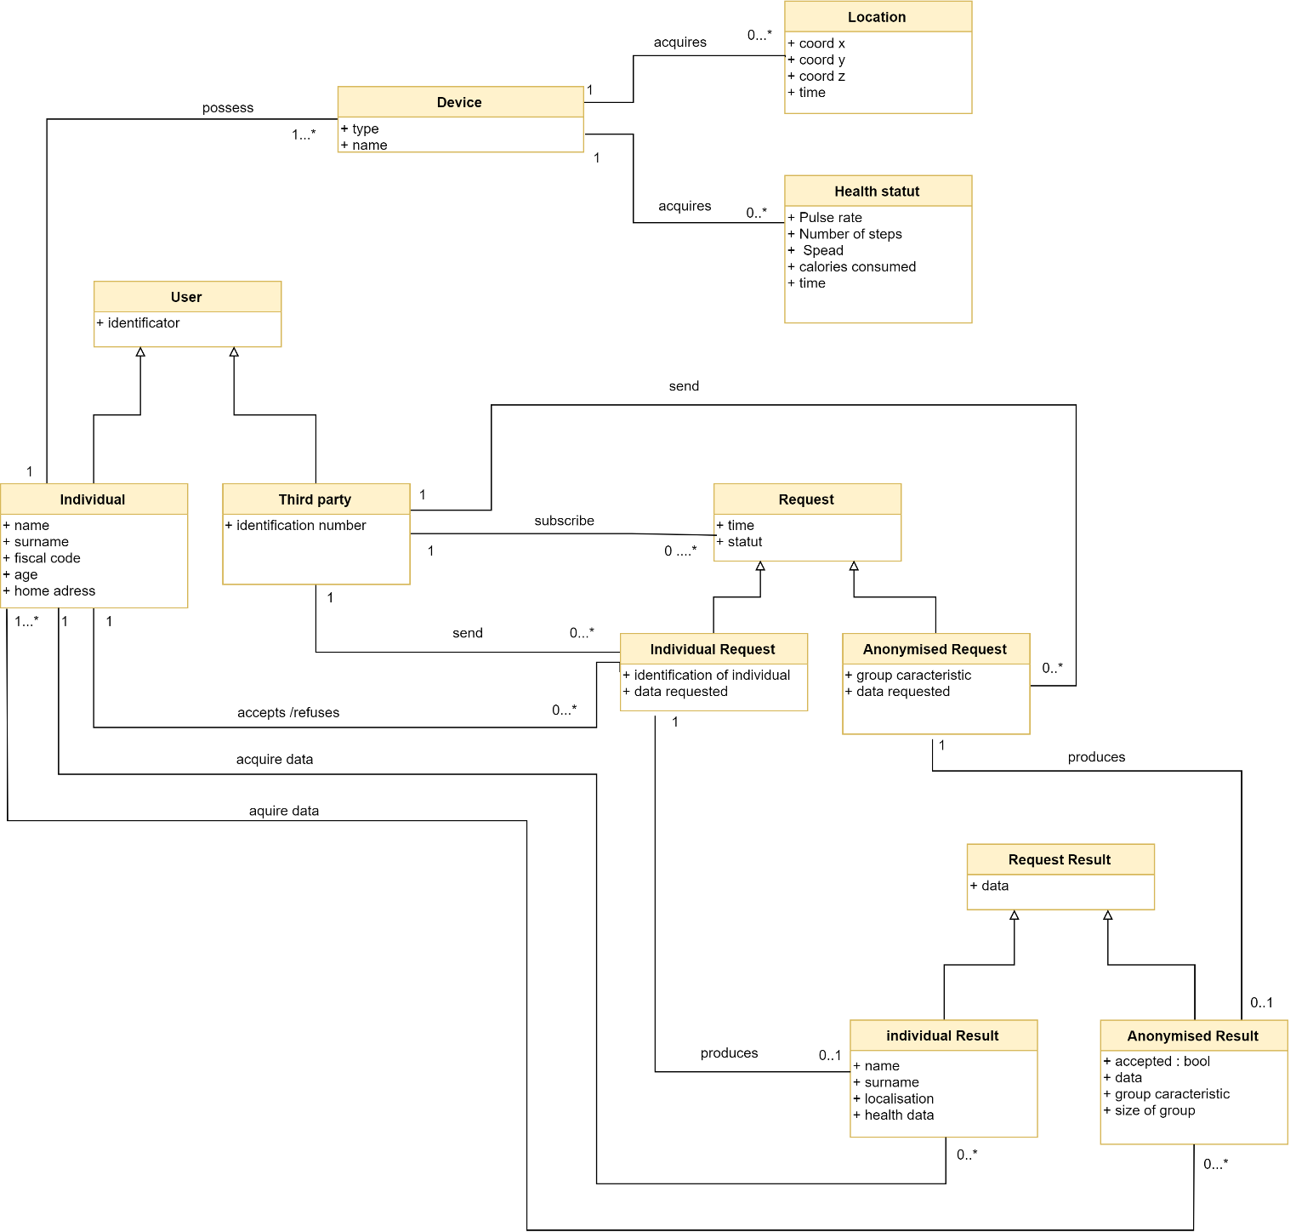

Figure 1: Class Diagram Data4Help

As we can see, the project is constituted by four main elements : The users, the requests, the results of those requests and the data acquired by the individual’s personal devices.

The central element of the service Data4Help is the request management process. For this reason, we choose to provide a state diagram which focuses on changes occurring in the class Request :

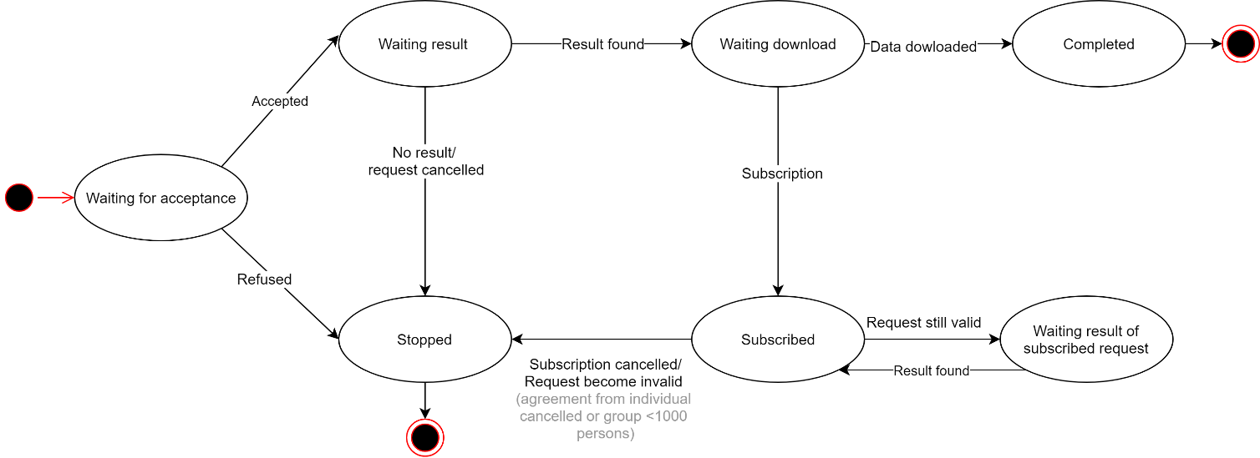

Figure 2: State Diagram : REQUEST

Once created a request can either be stopped or accepted. In the case of an individual request, the request is stopped if the individual refuses it ; and in the case of a anonymized request, the request is stopped if the number of individuals is lower than 1000. Otherwise the request is accepted.

An accepted request can be stopped if it is cancelled or if no result is produced (for example, if the request concerns an individual who do not use the application anymore). If the request produces a result, the request enters the state “Waiting download”. A request waiting for download enters the final state “Completed” once the data has been downloaded. If the request is subscribed, then it enters in a cycle where the result of the request is continuously produced ; as long as the request stays valid.

## Product functions

In order to fulfills the goals, the main functions that the service Data4Help should offer to third parties are the possibility for third parties to make anonymized and individual requests and to subscribe to them. Moreover, the main functions that the service Data4Help should offer to individuals are the possibility to see their data and to accept or refuse requests. In this paragraph, those main product functions are more precisely specified from the perspective of the third party and of the individual

Third party

The request management is the center of the service Data4Help. Indeed, the service has to allow third parties to make two types of requests: anonymized requests and individual requests. Moreover, the system must allow third parties to subscribe to the requests that have been accepted

Individual

The system must provide an interface for individual that allows them to consult their health data.

Furthermore, at any time, third parties should never have access to data of specific individuals without their agreement. This implies that for an individual request to be accepted, the individual concerned must give his agreement. The consequence is that the system must allow individuals to accept or refuse requests. Another consequence is that an anonymized request must be accepted by the system only if the number of individuals whose data satisfy the request is higher than 1000.

## Users characteristics

The users of the service Data4Help are Individuals, third parties and the manager of the service.

* **Manager**: The manager can access all functionalities of the system such as login, logout, accept or refuse the registration of a third party, add user, delete user.
* **Individual:** An individual is a person who download the app Data4Help on his smartphone and agrees that TrackMe acquires his data. An individual can access the functionalities: register, login, logout, consult his health data, accept and refuse requests from third parties
* **Third party**: A third party is an entity that desire acquiring data. It can be a company, an organization or a person (a student, a researcher…). A Third-party can access the functionalities: request for individual’s data (on specific individuals or on anonymized groups of more than one thousand persons), register, login, logout and subscribe to an already accepted request.

## Assumptions, dependencies and constraints

### Domain assumptions

[D.1] Fiscal code is unique

[D.2] The data recorded by external devices (smartphone and smartwatches) are assumed to be correct.

[D.3] A smartwatch can detect it has been removed from the wrist which disable the data recording.

[D.4] For a account, there is only one individual.

### Constraints

[CON.1] The Price of the must not exceed 85.000,00 €.

[CON.2] The system must be delivered before 12 October 2019.

[CON.3] With the delivery of the system, it must be also submitted a user manual that:

* + Should be written that is understandable for all users.
  + Should provide screenshots of the user interface and explain its various components.
  + Should contain information about the system and how to operate the system.

# Data4Help : Specific requirements

## External interfaces requirements

### User interfaces

The two end users are third parties and individuals. Both types of users have to register to Data4Help in order to be able to use the services.

In this section, the user interfaces are presented for both types of users. The phases presented are :

* For third parties
  + Registration
  + Making request on specific individual or on anonymized groups
  + Subscribing
* For individuals
  + Registration
  + Observation of own data
  + Accepting/refusing requests

Individuals will use Data4Help on their smartphones. Indeed, the smartwatch is the device used to acquire data but the small size of the screen makes it unsuitable to accept/refuse requests.

#### Registration phase

The third party are more likely to register to Data4Help using a computed while individuals are more likely to register to Data4Help using their smartphone. The interface is the same whether the user uses a computer or a smartphone. So, only the smartphone version is presented here. For the computer version, the content is the same, only the dimension changes.

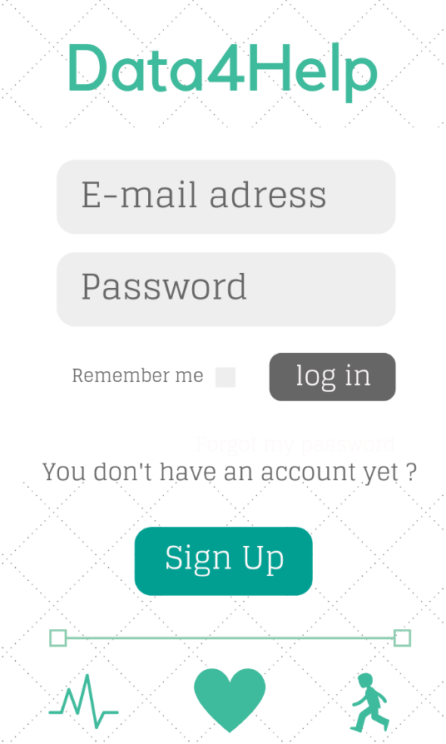 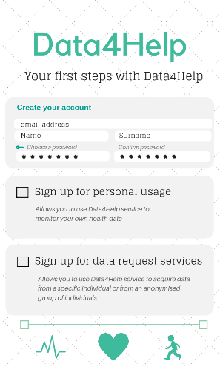

Figure 3 : Sign up for both types of users Figure 4: Log in and Log up for both types of users

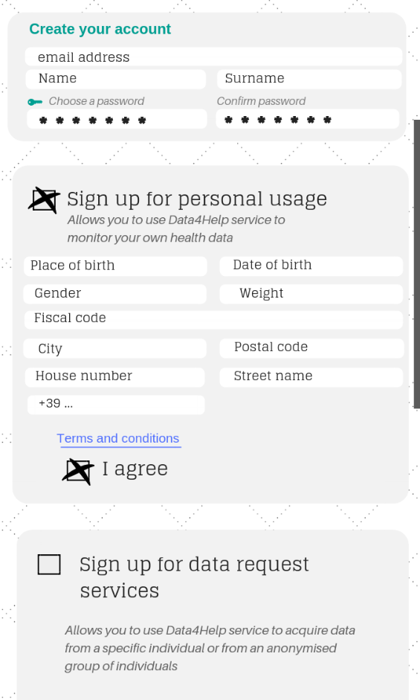 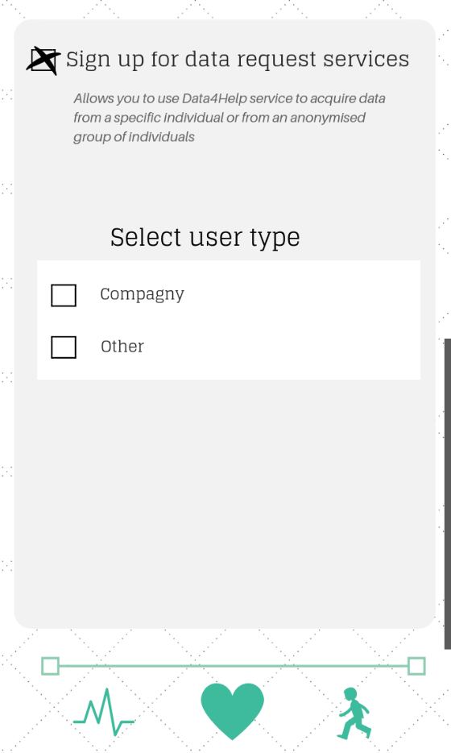

Figure 5 : Sign up for individuals Figure 6: Sign up for third parties

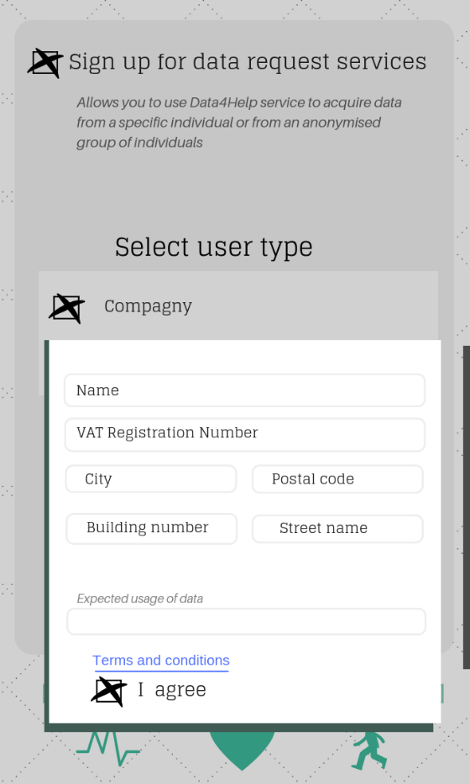 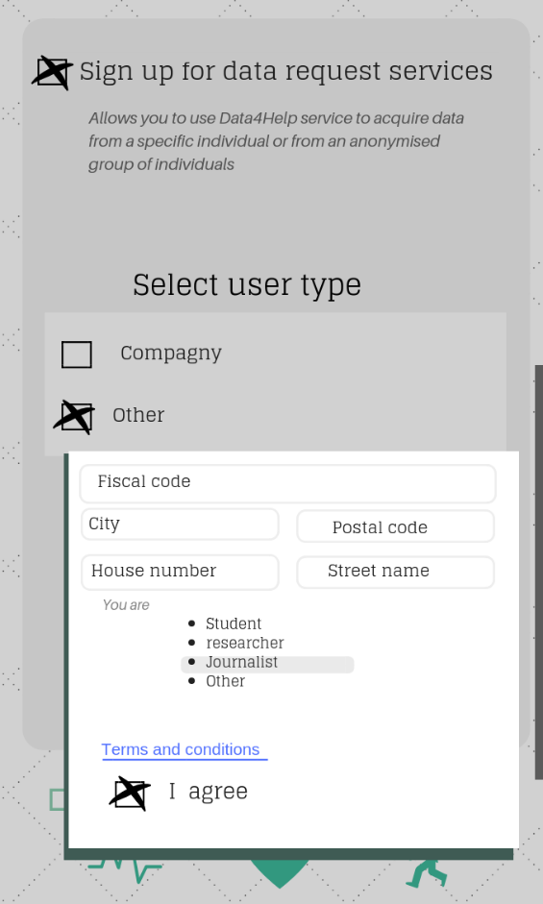

Figure 7 : Sign up for third parties (companies) Figure 8 : Sign up for third parties (Others)

#### Smartphone interface for individuals

Individuals will use their smartphone to keep track of their health data and to accept or refuse requests from third parties.

Through the smartphone application, individuals also have the possibility to subscribe to AutomatedSOS.

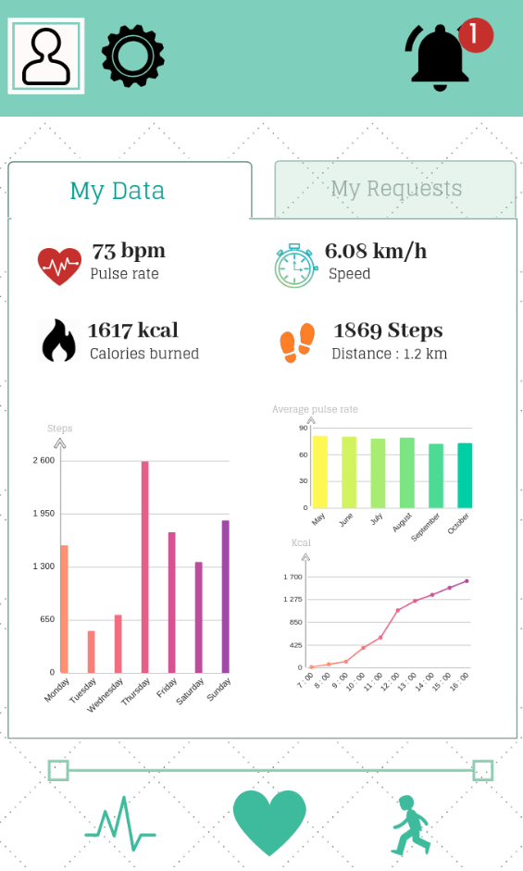 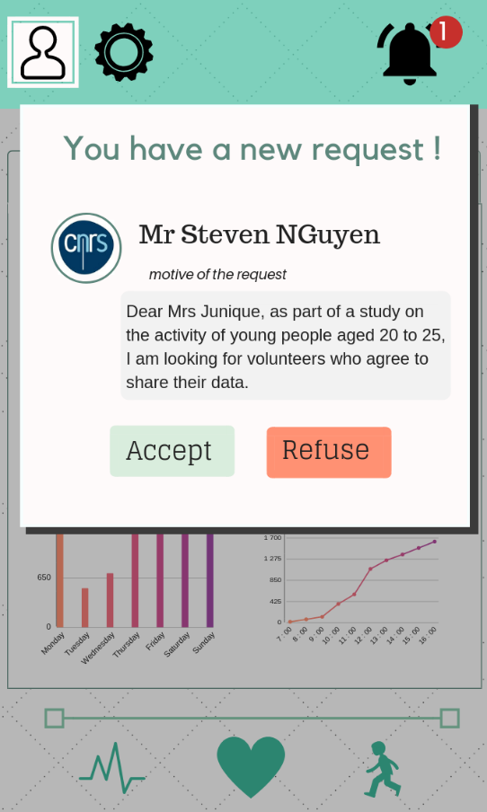

Figure 9 : Health data visualization for individuals Figure 10 : Notification for new request

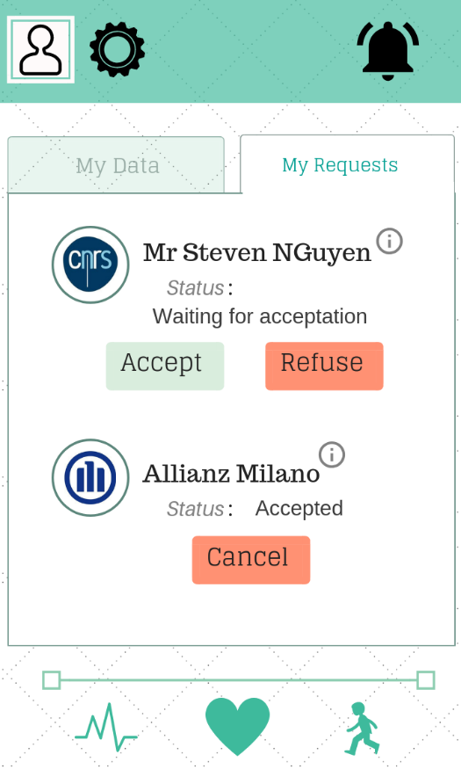

Figure 11 : Request management for individuals

#### Website interface for third parties

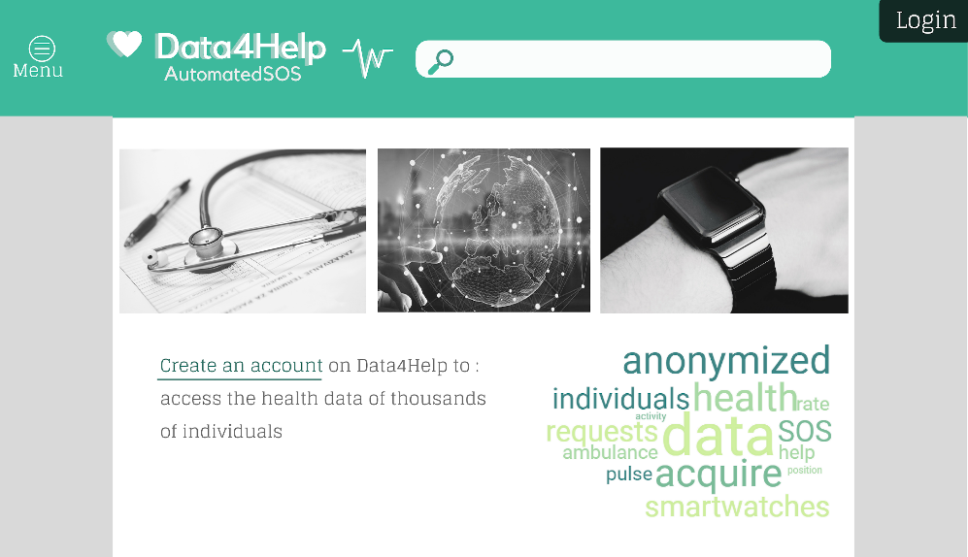

Figure 12: Home page of Data4Help Website

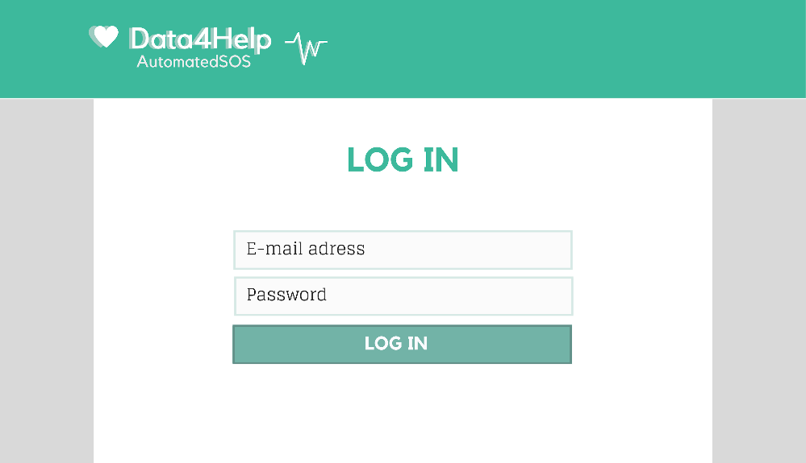

Figure 13 : Data4Help website : Log in for third parties

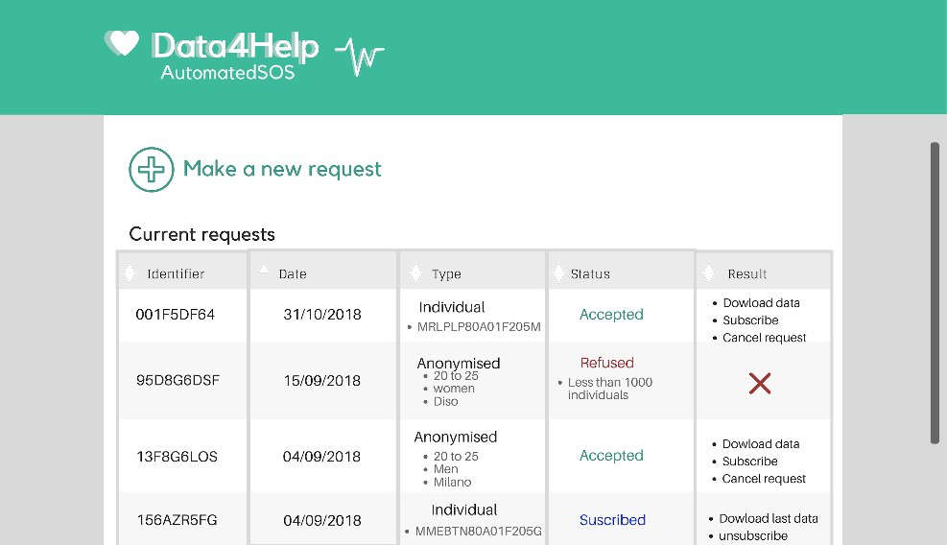

Figure 14 : Data4Help website : Request management for third parties

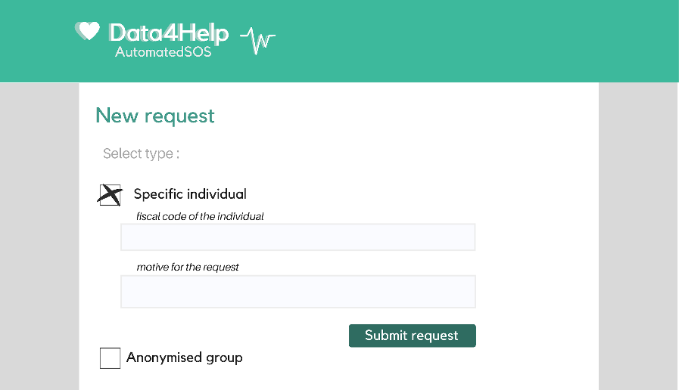

Figure 15 : Data4Help : make a new request for a specific individual

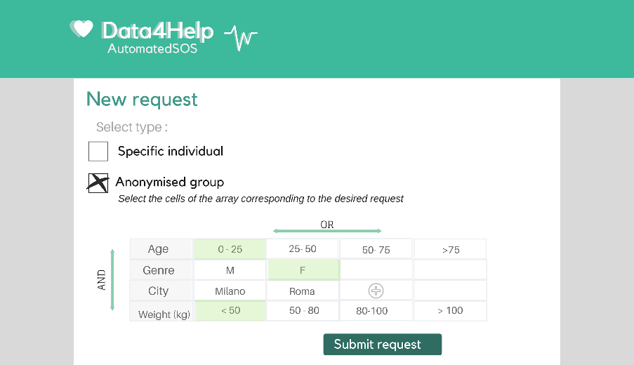

Figure 16 : Data4Halp : make a new request for a anonymised group

### Hardware interfaces

Data4Help is a software-based service application that do not use any hardware interfaces.

### Software interfaces

The service Data4Help will provide a web API that allow third parties to directly download data from accepted request using their request id and their password.

### Communication interfaces

Data4Help uses communication channels:

* Smartphone to smartwatch: Bluetooth connection.
* Smartphone to server: The smartphone application uses https request to receive and send data to the data server. The data server manages and stores all sensitive data. The application only accesses sensitive data using the https API.
* The Data4Help website also sent and request data from the https API.

## Functional requirements

1. The system must allow users to register as third parties.
   1. The system must obligate the third parties to choose a password.
   2. The system must obligate the third parties to provide an E-mail address.
   3. The system must obligate the third parties to specify whether they are a company or another type of third party.
   4. The system must request compagnies to provide a name.
   5. The system must request compagnies to provide a VAT registration number.
   6. The system must request compagnies to provide an address.
   7. The system should request other types of third parties to specify their occupation (student, researcher, data scientist...)
   8. The system must request other types of third parties to provide a fiscal code
   9. The system must request other types of third parties to provide an address.
2. The system must allow users to register as individuals.
   1. The system must obligate individuals to choose a password.
   2. The system must obligate individuals to provide an E-mail address.
   3. The system must obligate individuals to specify their name.
   4. The system must obligate individuals to provide their surname.
   5. The system must obligate individuals to provide a fiscal code.
   6. The system should obligate individuals to provide an address.
   7. The system should ask individuals to provide additional information (place of birth, date of birth, gender, weight)
3. The system must acquire health data of individuals who register to the service
   1. The system must be able to acquire health data from a smartwatch and to send it to a data server.
   2. The system
   3. The system must be able to store sensitive data securely

* **[G 1] : Third parties must be able to request to access to the data of specific individuals or to anonymized groups of individuals.**

1. The system must allow third parties to make requests about specific individuals identified by their fiscal code.
2. The system must allow third parties to make requests about groups of individuals.

* **[G 2] : At any time, third party should never have access to data of specific individuals without their agreement.**

1. In the case of a request on a specific individual, the system must check for the individual agreement before making the data available for the third party.
   1. The system must send a notification to the specific users whose data are requested and make him choose between accepting or refusing the request
   2. If a third party made a subscription to a request and the user cancels his agreement to share his data, the system must cancel the subscription.
2. In the case of a request on a group of persons, the system must anonymize the data.
   1. The system must refuse any request on a group of persons for which the number of individuals whose data satisfy the request is lower than 1000.
   2. If a third party made a subscription to a request on a group of persons and at some point, the number of individuals whose data satisfy the request become lower than 1000, the system must cancel the subscription.

* **[G3] : Third parties must have the possibility to subscribe to new data if their request is accepted.**

1. The system must allow third parties to subscribe to the requests that have been accepted
   1. If a third party subscribed to a request, the system must make the data corresponding to the request available for the third party as soon as they are produced.

* **[G 4] : Individuals must be able to consult their data and accept/refuse requests**

1. The system must provide an interface for individual that allows them to consult their health data

## Scenarios

PUT THE SCENARIOS HERE

## Uses cases

In this section two use cases diagrams are presented, one for the individuals and one for the third parties.

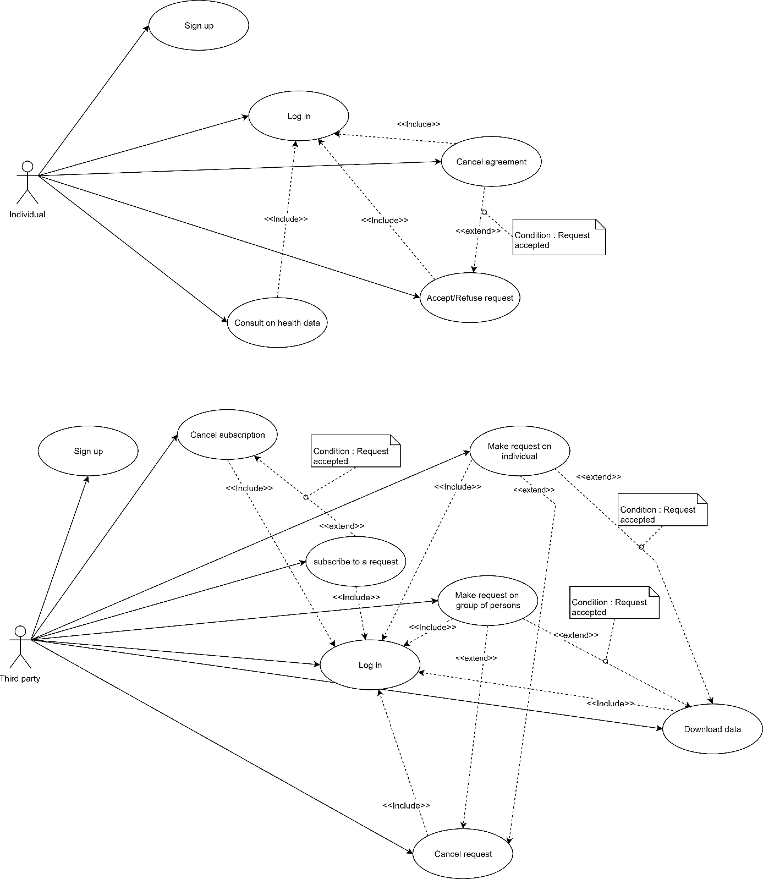

|  |  |  |
| --- | --- | --- |
| LOG IN | | |
| Actor | Individual | |
| Entry Conditions | The individual is already registered to the service Data4Help and has the application installed on his/her device  The system is ready | |
| Events flow | INDIVIDUAL STEPS | SYSTEM STEPS |
| 1. The individual starts the app  3. In the homepage of the app, the individual enters his E-mail address and his password  4. In the homepage of the app, the individual presses the “Log in” button | 2. The system starts the login phase |
| Exit conditions | The Individual logs in the app. | |
| Exceptions | - If the connection is lost, the app page is reloaded and the individual has to fill it again.  - If the email is not in the database, the app page is reloaded with an error message.  - If the password does not correspond to the email in the database, the app page is reloaded with an error message. | |

|  |  |  |
| --- | --- | --- |
| SIGN UP | | |
| Actor | Individual | |
| Entry Conditions | The individual has installed the application on his/her device | |
| Events flow | INDIVIDUAL STEPS | SYSTEM STEPS |
| 1. The individual presses the “Sign up” button on the home page of the app  3. The individual writes his E-mail address, his name, his surname and his password twice.  4. The individual presses the button “Sign up for personal usage”  5. The individual fill all the mandatory fields and provide the necessary information    6. The individual reads the terms and conditions and accepts it. | 2. The system starts the registration phase  7. The system saves the data |
| Exit conditions | The Individual logs in the app. | |
| Exceptions | - If the connection is lost, the app page is reloaded and the individual has to fill it again.  - If the E-mail address is already in the database, the app page is reloaded with an error message | |

|  |  |  |
| --- | --- | --- |
| COnsult health data | | |
| Actor | Individual | |
| Entry Conditions | The Individual is logged in the app | |
| Events flow | INDIVIDUAL STEPS | SYSTEM STEPS |
| 1. The individual presses the “My data” tab on the app | 2. The system update the last data |
| Exit conditions | The individual can visualize his data | |
| Exceptions | - if the system cannot acquire data from the external device (the smartwatch), the new data is not printed on the screen and the individual receive an error notification. | |

|  |  |  |
| --- | --- | --- |
| Accept/refuse request | | |
| Actor | Individual | |
| Entry Conditions | The Individual is logged in the app and has received a request from a third party. | |
| Events flow | INDIVIDUAL STEPS | SYSTEM STEPS |
| 1. The individual presses the “My requests” tab on the app  2. The individual consults the requests he has received  3. The individual presses the button “Accept” or “Refuse” | 4. The system saves the answer of the individual  5. The system updates the status of the request  6. The system inform the third party of the new status of the request |
| Exit conditions | The status of the request is updated | |
| Exceptions | - If the local application cannot send the individual’s answer to the server then the local application sends an error message to the individual asking him to answer the request another time. | |

|  |  |  |
| --- | --- | --- |
| Cancel agreement | | |
| Actor | Individual | |
| Entry Conditions | The Individual is logged in the app and has accepted a request from a third party | |
| Events flow | INDIVIDUALS STEPS | SYSTEM STEPS |
| 1. The individual presses the “My requests” tab on the app  2. The individual consults the requests he has accepted  3. The individual presses the button “cancels” | 4. The system saves the modification  5. The system updates the status of the request  6. The system inform the third party of the new status of the request |
| Exit conditions | The status of the request is updated | |
| Exceptions | - If the local application cannot send the update to the server then the local application sends an error message to the individual asking him to repeat the process another time. | |



|  |  |  |
| --- | --- | --- |
| LOG IN | | |
| Actor | Third party | |
| Entry Conditions | The third party is already registered to the service Data4Help | |
| Events flow | THIRD PARTY STEPS | SYSTEM STEPS |
| 1. The third party opens the Data4Help website  2. the third party clicks on the “log in” button  3. In the login page, the third party enters his E-mail address and his password  4. In the login page, the third party presses the “log in” button | 3. The system starts the login phase |
| Exit conditions | The third party is logged in the website | |
| Exceptions | - If the connection is lost, the website page is reloaded and the third party has to fill it again.  - If the email is not in the database, the page is reloaded with an error message.  - If the password does not correspond to the email in the database, the page is reloaded with an error message. | |

|  |  |  |
| --- | --- | --- |
| SIGN UP | | |
| Actor | Third party | |
| Entry Conditions | The third party has opened the Data4Help webpage on his browser | |
| Events flow | THIRD PARTY STEPS | SYSTEM STEPS |
| 1. The third party clicks on the button “create an account” in the website home page  3. The third party writes his E-mail address, his name, his surname and his password twice.  4. The third party clicks the button “Sign up for data request services”  5. The third party specify his user type (company or other)  6. The third party fill all the mandatory fields and provide the necessary information    7. The third party reads the terms and conditions and accepts it. | 3. The system starts the registration phase  6. The system saves the data |
| Exit conditions | The third party logs in the app. | |
| Exceptions | - If the connection is lost, the page is reloaded and the third party has to fill it again.  - If the E-mail address is already in the database, the page is reloaded with an error message. | |

|  |  |  |
| --- | --- | --- |
| MAke request on individual | | |
| Actor | Third party | |
| Entry Conditions | The third party is logged in the web site | |
| Events flow | THIRD PARTY STEPS | SYSTEM STEPS |
| 1. The third party clicks on the button “Make a new request”  3. The third party selects the type “specific individual” by clicking on the corresponding button  4. The third party specify the fiscal code of the individual and the motive of the request | 2. The system displays the “New request” window    5. The system add the new request to the request history with the status “waiting for acceptation”  6. The system send the request to the individual |
| Exit conditions | The request is added to the request history with the status “waiting for acceptation” | |
| Exceptions | -If the fiscal code specified by the third party is not valid or if the field has not been filled the page is reloaded with an error message. | |

|  |  |  |
| --- | --- | --- |
| MAke request on group of persons | | |
| Actor | Third party | |
| Entry Conditions | The third party is logged in the web site. The third party is on the request history page | |
| Events flow | THIRD PARTY STEPS | SYSTEM STEPS |
| 1. The third party clicks on the button “Make a new request”  3. The third party selects the type “anonymized group” by clicking on the corresponding button  4. The third party build his request selecting among the various criterion available. | 2. The system displays the “New request” window    5. The system verify that the number of people whose data satisfy the request is higher than 1000  6. The system add the new request to the request history with the status “Accepted |
| Exit conditions | The new request is present in the request history with the status “Accepted – waiting for result” | |
| Exceptions | - If the number of people whose data satisfy the request is lower than 1000, the request is refused. In this case the system adds the new request to the request history with the status “Refused: less than 1000 individuals”. | |

|  |  |  |
| --- | --- | --- |
| subscribe to a request | | |
| Actor | Third party | |
| Entry Conditions | The third party is logged in the web site and at least one of his requests has been accepted. The third party is on the request history page | |
| Events flow | THIRD PARTY STEPS | SYSTEM STEPS |
| 1. The third party search in his request history for the request to which he wants to subscribe and clicks on “subscribe” | 2. The system updates the status of the request |
| Exit conditions | The third party is subscribed to the request. | |
| Exceptions | -If the third party want to subscribe to a request about an individual and the individual does not use the service Data4Help anymore, the system does not update the status of the request and print an error message.  - If the third party want to subscribe to a request about an individual and the individual has cancelled his agreement, the system does not update the status of the request and print an error message.  - If the third party want to subscribe to a request on a group of persons and the number of people whose data satisfy the request is lower than 1000, the system does not update the status of the request and print an error message. | |

|  |  |  |
| --- | --- | --- |
| cancel subscription | | |
| Actor | Third party | |
| Entry Conditions | The third party is logged in the web site and has at least one subscription. The third party is on the request history page | |
| Events flow | THIRD PARTY STEPS | SYSTEM STEPS |
| 1. The third party search in his request history for the request to which he wants to unsubscribe and clicks on “unsubscribe” | 2. The system update the status of the request |
| Exit conditions | The third party is not subscribed to the request. | |
| Exceptions |  | |

|  |  |  |
| --- | --- | --- |
| cancel request | | |
| Actor | Third party | |
| Entry Conditions | The third party is logged in the web site. The third party is on the request history page | |
| Events flow | THIRD PARTY STEPS | SYSTEM STEPS |
| 1. The third party search in his request history for the request to which he wants to cancel and clicks on “cancel request” | 2. The system update the status of the request |
| Exit conditions | The status of the request is updated | |
| Exceptions |  | |

|  |  |  |
| --- | --- | --- |
| download data | | |
| Actor | Third party | |
| Entry Conditions | The third party is logged in the web site and has at least one accepted request. The third party is on the request history page | |
| Events flow | THIRD PARTY STEPS | SYSTEM STEPS |
| 1. The third party search in his request history for the request to which he wants to download data and clicks on “download data” | 2. The system send the data file to the user’s browser |
| Exit conditions | The third party has received the data | |
| Exceptions | If the user interrupts the download, the webpage prints an error message with a button retry. | |

## Sequence diagrams

This section contains the sequence diagrams description of four of the most important functions of the service Data4Help which are making individual and anonymized requests and subscribing to them.

* Make an individual Request

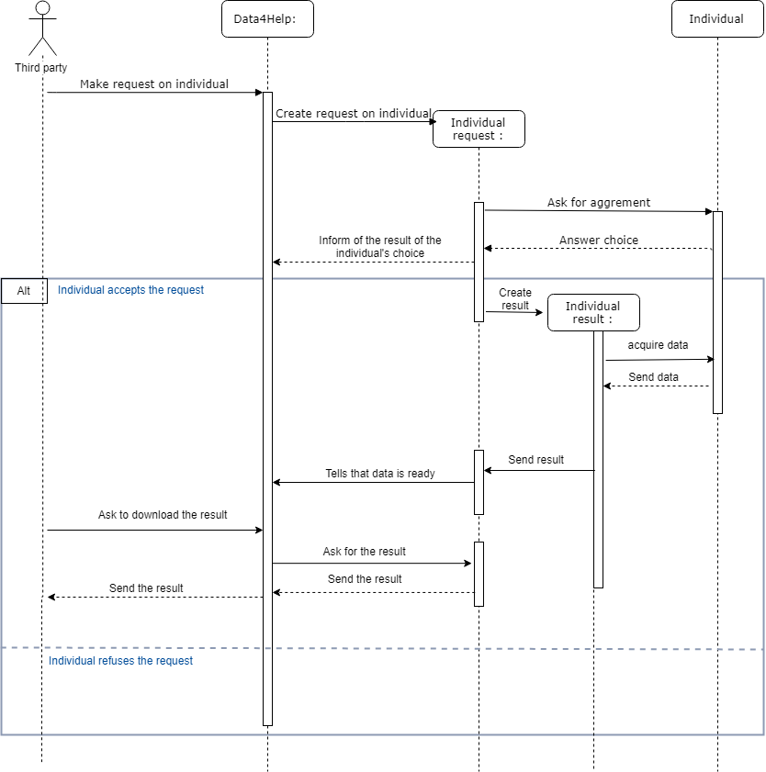

Figure 17 : sequence diagram : make an individual request

* Make an anonymized request

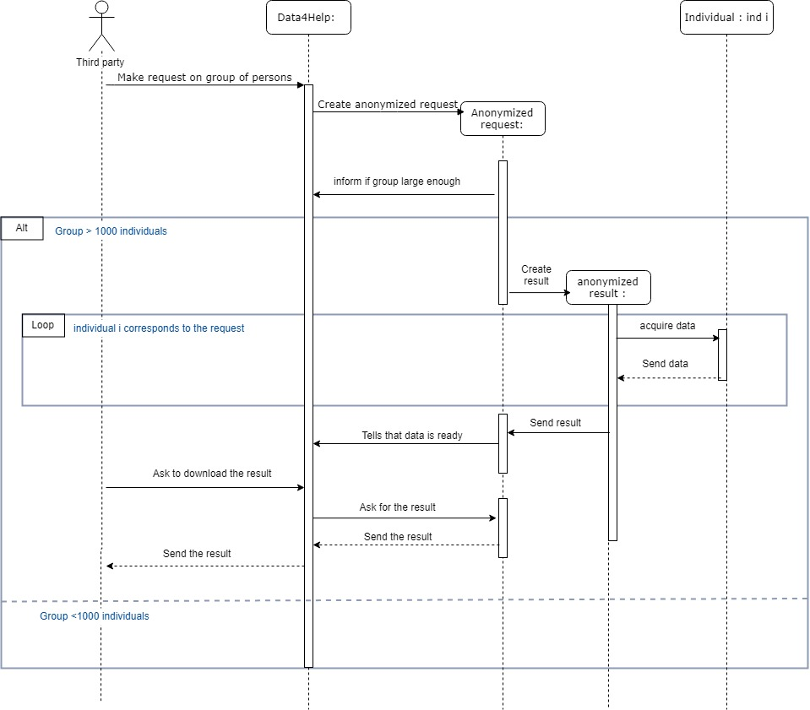

Figure 18 Sequence diagram request anonymized group

* Subscribe to an anonymized request

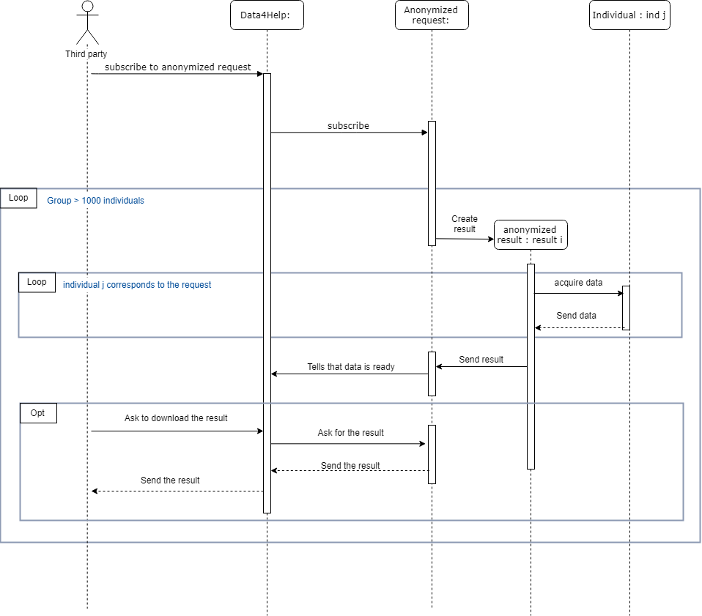

Figure 19 Sequence diagram subscription to anonymized request

* Subscribe to an individual request

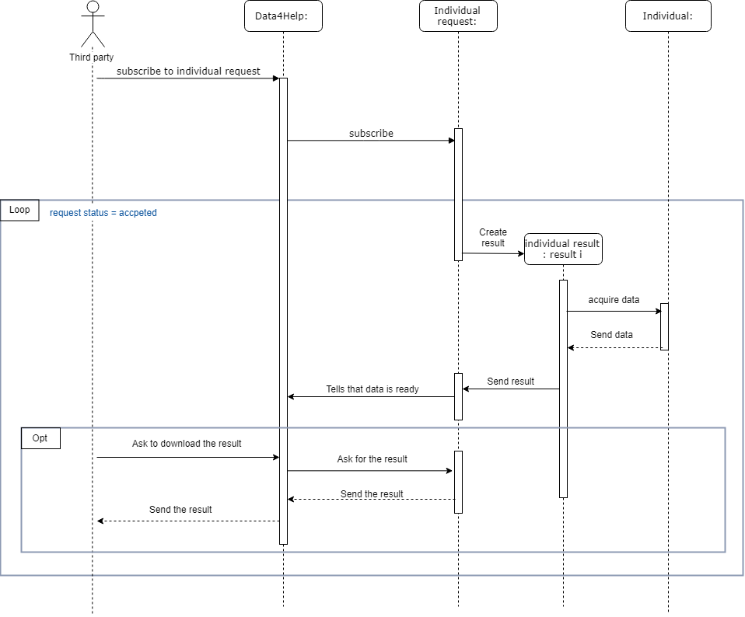

Figure 20 sequence diagram subscription to individual request

## Performance requirements

### Performance Characteristics

* From the moment new data is received, all the actions that the system must perform must have a total duration strictly under five seconds.

The quality of performance depends on:

* System should automatically update after every transaction.
* More than five attempts at login and failure will produce a red flag to system administrator.
* Data should be secured and backed up every quarter hour.
* Power supply should have a backup and a disaster recovery plan.

### Error Handling and Extreme Conditions

In a real-life situation, the system input is influenced by the environment in which it operates. The following requirements are specified to provide a certain level of robustness when the system is dealing with errors and invalid input.

* The system must be able to recognize abnormal input.
* The system must activate the alarm when third parties’ companies are using data in an inappropriate way.

## Design constraints

### Standards compliance

### Hardware limitations

The computer that will run the system has to meet the following requirements:

- Memory: minimum 4 GB RAM

- Processor: minimum 1.8 GHz Intel or an equivalent

Also there will be a mobile application for the users and in order to run this application these are the minimum hardware limitations in order to use the application correctly , also these are the minimum limitation for the smart watch if it will be used and connected to the mobile phone .

-Memory: 2 GB RAM or higher

-Pedometer sensor

-Heart rate and oxygen sensor

-Global positioning system (GPS)

## Software system attributes

### Reliability

Software Reliability is the probability of failure-free software operation for a specified period of time in a specified environment , and this attribute is very important for this software as it is related to the health of people , during this rasd we will demonstrate that in some cases we will send more than one request to be sure that these request reached the correct destination and they started taking an action.

### Availability

Availability is defined as the probability that the system is operating properly when it is requested for use. As described before in the Reliability section (E.1) , that our system will be able to monitor health conditions . so our system will be available 24 hours 7 days aweek.

### Security

Access to Data4Help is restricted by passwords with the support of User Manager. You can define the roles to control any third party. Besides, sensitive information can be viewed, printed or changed only by using an admin password.

### Maintainability

Maintainability incorporates such concepts as changeability, modularity, understandability, testability, and reusability. As the system may need a lot of modification through the time because of the changing in the people life and attitudes , all our software is commented in a very simple way that can be understood easily , also a good documentation is delivered explaining every function and its job clearly.

### Portability

This version of application will wonk on android phones , but the third party can use the web site from any device , in a next version we will implement a version for apple products .

AutomatedSOS

# AutomatedSOS : Overall description

## Product perspective

The service AutomatedSOS is build on top of Data4Help, thus all the functionality present in Data4Help are also present in the service AutomatedSOS. To satify the goals of the service AutomatedSOS, two additional class are needed: Individual SOS service and ambulance service.

A global overview of the major component of the AutomatedSOS service is given by the class diagram

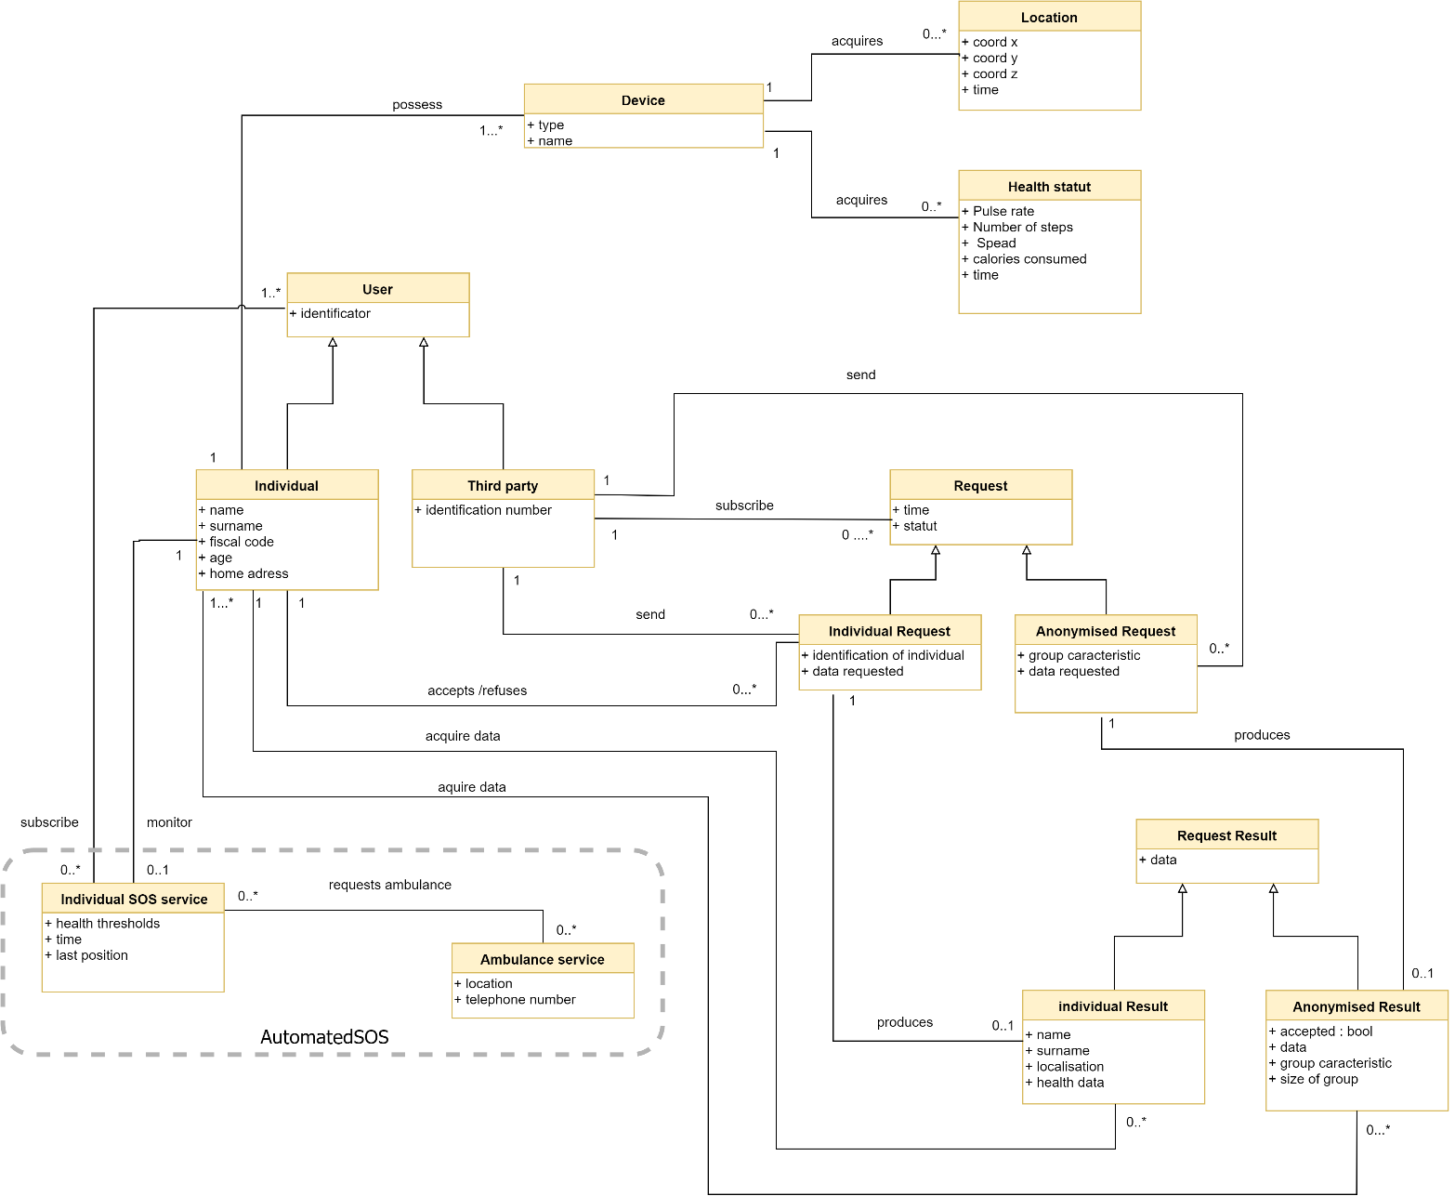

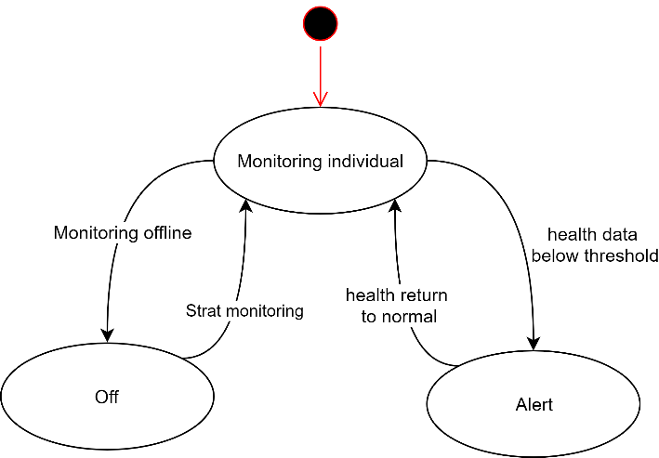

## Product functions

## User characteristics

Same as Data4Help

## Assumptions, dependencies and constraints

To be completed

Smartwatch mandatory

AutomatedSOS choose de threshold

Watch can detect when removed

Users must first be registered to Data4Help

Sos sent through sms

User equipped with system with GPS and pertinent health data ( pulse rate, fall detection..)

Si la montre est enlevéd : pas de data (cad pas de poul=0)

Automated SOS

Services d’ambulance capables de recvevoir des sos depuis l’apli

# AutomatedSOS : Specific requirements

## External interfaces requirements

### User interfaces

The service AutomatedSOS is build on top of Data4Help, thus the interface is mainly the same. When an individual subscribes to AutomatedSOS, this add a new window to the app : “My thresholds” where the user can consult the thresholds below which the SOS will be sent. The rest of the app is unchanged.

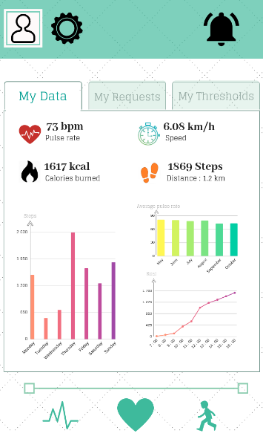 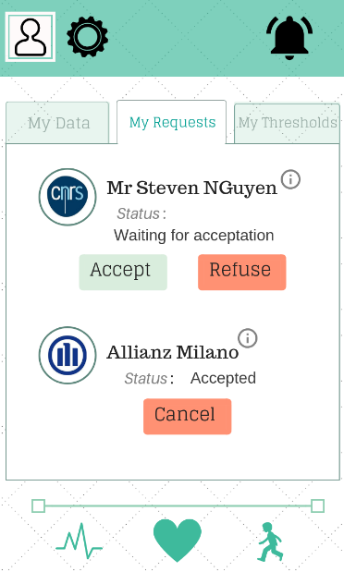

Figure 21 : AutomatedSOS for individuals (data visualization) Figure 22 : AutomatedSOS for individuals (Requests)

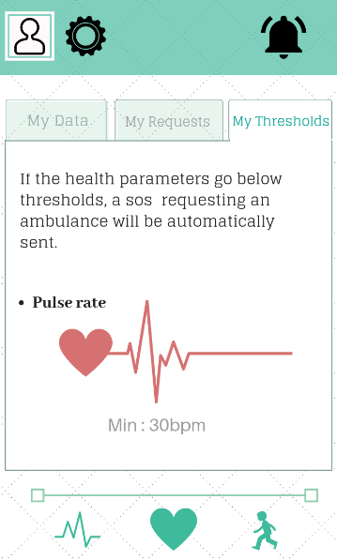

Figure 23 : AutomatedSOS for individuals (my thresholds)

Individuals who subscribe to AutomatedSOS have the possibility to also download an application on their smartwatch. This is not mandatory for the data acquisition and for the sending for the SOS. This application allow the user to see his health status and to be notified instantly when an SOS is sent.

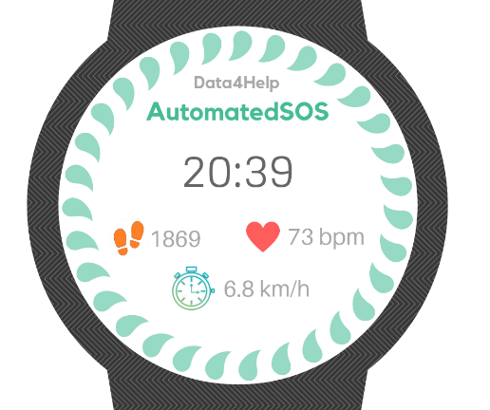 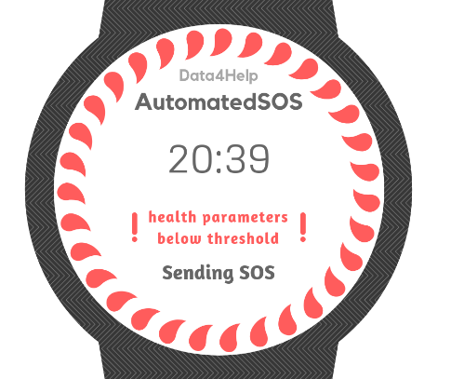

Figure 24 : Smartwath normal health status Figure 25 : Smartwatch : health status below thresholds

### Hardware interfaces

To be completed

### Software interfaces

To be completed

### Communication interfaces

To complete

Communication with ambulance service

## Functional requirements

All the functional requirements listed in the section Data4Help are also requirements of AutomatedSOS. In this section, only the requirements specific to the service AutomatedSOS are listed.

1. The service Data4Help must provide an interface for allowing individuals to register to the new service AutomatedSOS.
2. The service AutomatedSOS must allow subscribers to cancel their subscription

* **[G 5] : An ambulance is requested to the location of the customer with a reaction time below 5 seconds from the time the parameters are below threshold**

1. The system must detect when the health data of subscribers are below threshold
2. If the health data of a subscribed customer, the system must send an SOS to the ambulance service indicating the position of the user.

## Uses cases

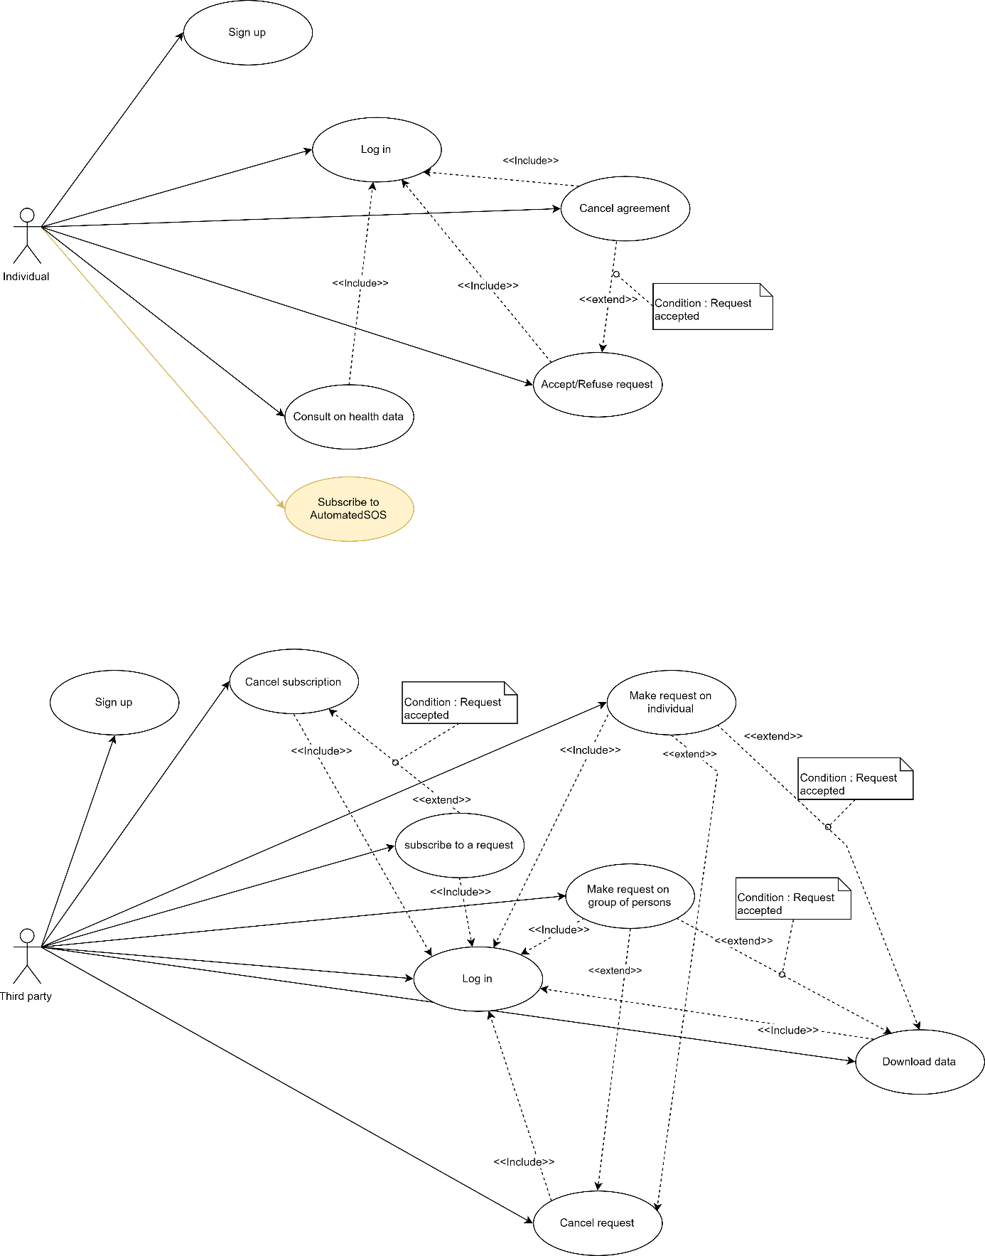

|  |  |  |
| --- | --- | --- |
| Subscribe to AutomatedSOS | | |
| Actor | Individual | |
| Entry Conditions | The individual is already registered to the service Data4Help and has the application installed on his/her device  The system is ready | |
| Events flow | INDIVIDUAL STEPS | SYSTEM STEPS |
| 1. The individual clicks on the “subscribe to AutomatedSOS” button either on the options page or in the notification window.  3. The user read and accept the terms and conditions. | 2. The system starts the registration phase  3. The system checks if the account of the user is linked to a smartwatch |
| Exit conditions | The user is subscribed to AutomatedSOS | |
| Exceptions | If the Data4Help account of the user is not linked to a smartwatch, the system send an error message “Smartwatch not found”. | |

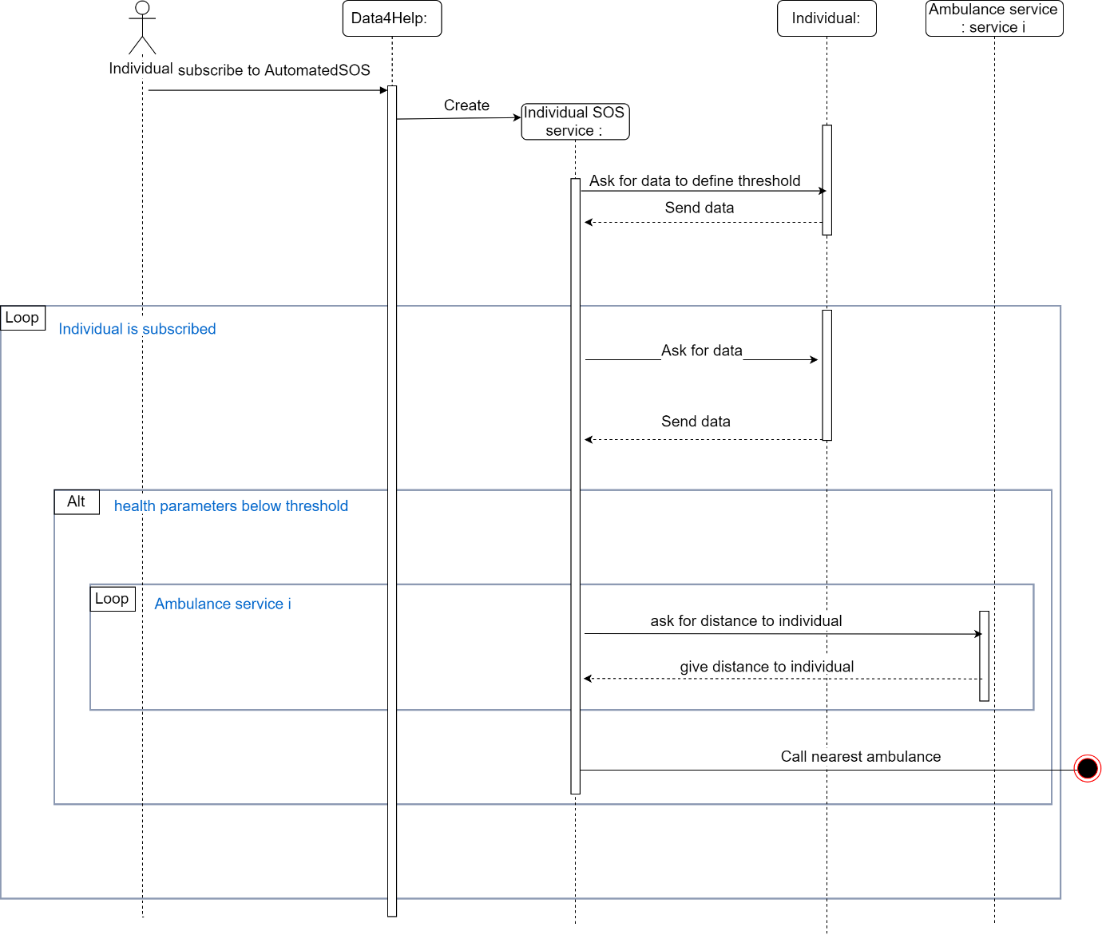

## Performance requirements

Same as Data4Help

## Design Constraints

### Standards compliance

### Hardware limitations

Same as Data4Help

### Any other constraint

## Software system attributes

Same as Data4Help

# Formal analysis using Alloy

# Effort spent

# References